**Exercise 1 - Dawson**

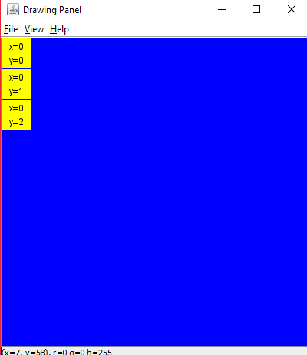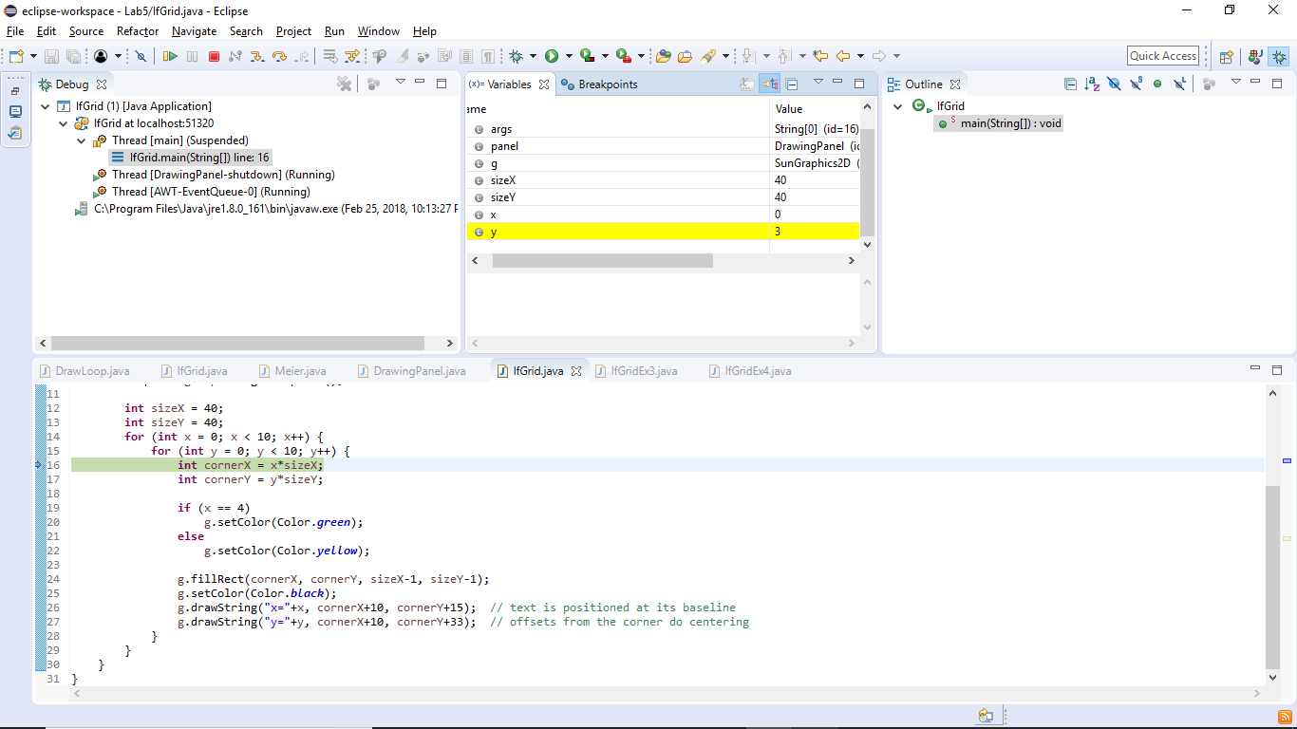

**Exercise 2 - Dawson**

X = 4 because the program has run until it hit the break point, and was not run prior to this because x != 4 so therefore it was skipped.

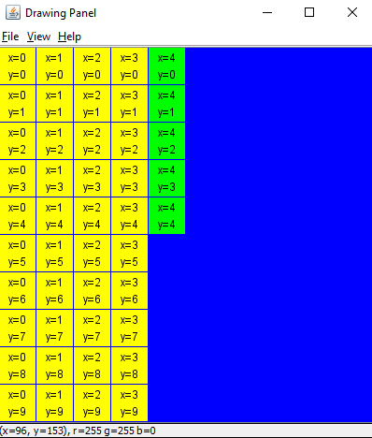

Although y = to 5 its is not displayed because the breakpoint is prior to the box being drawn and the x, y text being displayed.

**Exercise 3 - Dawson**

if (x >= 2 && x < 8 && y >= 2 && y <8) {

g.setColor(Color.green);

}

else {

g.setColor(Color.yellow);

}

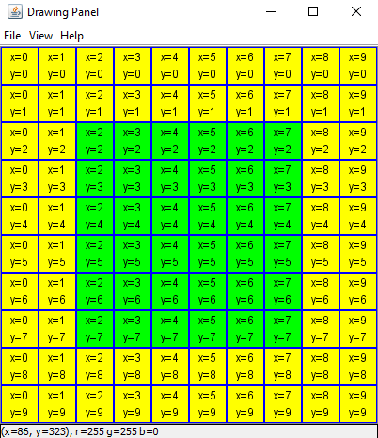

**Exercise 4 - Dawson**

g.setColor(Color.yellow);

if ((x == 2) || (x == 7)){

if ((y > 0) && (y < 9)){

g.setColor(Color.green);

}

}

